Rancho Mastatal Updates
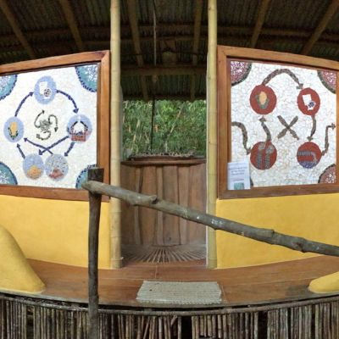
Lime Plasters

Second Trimester 2015
By moving to a trimester format for our newsletter, we're able to take advantage of a faster Internet connection while visiting family and friends in the States to get 2 of our 3 newsletters prepared and sent to everyone. We expect this to reduce a bit of stress while saving time and increasing the quality of this publication. The entire core team currently finds themselves away from the Ranch working in temperate climates and reconnecting with family and friends. SCOTT and NIC will be the first to return to Mastatal in early November to run a large group focused on skills building with a new project called Winterline . This will be our first time working with this organization and we're hoping to develop a long-term relationship as our objectives align quite well. ROBIN, SOLE and I are presently in upstate NY and look forward to connecting with numerous people in our NE network over the next few months. This is an important time for us to catch up on administrative work, spend time with family, and recharge our mental and physical batteries as we plan for another busy year in Costa Rica. Our most recent season was on many fronts our most successful to date. We made some extraordinary improvements to our organizational structure that helped us to achieve a level of economic stability that we haven't experienced to date. Both our built and planted infrastructures continue to get stronger as our ability to make solid and effective decisions improves. We've also been well-served by a more acute willingness to let go of projects that have not been working for us and/or meeting our expectations. This has freed up time and energy to put into the systems that hold the most promise as many of them mature and start paying dividends. Next season will mark the first year that all of our apprentices are committed to our full-year program. We have essentially phased out our volunteer and internship programs in lieu of a more stable and in-depth educational offering. We've been encouraged and a bit surprised by the numbers of people worldwide that are looking for this type of long-term, hands-on, sustainability-oriented training designed to prepare participants for the challenges that they'll confront in the future. As a general rule, we are working to increase the length and depth of many of our educational programs. You can learn more about these efforts below in a great article written by SCOTT. We have hopes that our programs will one day be anchored by a semester long accredited course that we've been developing over the past year and are currently shopping around to various institutions that might be interested in championing such an endeavor. Please let us know if you know of anyone in or outside of academia that might be interested in speaking with us about our semester offering. We have also recently added a 4-month opportunity for natural building enthusiasts. NIC, the Ranch's head of construction, will be working closely with individuals interested in learning how to build a structure from foundation upwards. The Natural Building Certificate (NBC) starts in August, 2016. In stateside news, we continue to explore opportunities with our “Open to Possibilities” group as we think about how we can increase our positive impact in the country where we were born and raised through a food-based initiative in the Northeast. On a more personal note, Robin, Sole and I will have some big decisions to make in the coming years as Sole's educational needs evolve. She thoroughly enjoyed her first year in the elementary school in Mastatal though the timing of Costa Rica's school year may necessitate some changes in how and when we travel. We're also in the midst of taking the first concrete steps in designing and developing a new website. A former Ranch student, JON-PAUL D'AVERSA, is holding our hand as we begin to take the long overdue plunge into this enormous endeavor. We still have a few gaps in our 2016 calendar that we're looking to fill before our return to Mastatal in December. If you know any educators that take students or groups abroad or would like to explore this type of opportunity, please put them in touch with us! Enjoy this edition and keep us abreast of your goings on when you get the chance. Feel the Bern baby.
This month's update includes:
Program News: Hospitality or Hospital?
Building: Lime
Farm: Patterns for Experiential Learning
Food: What Next?
Community: Life as an Ex-Pat
Apprentice/Guest Contribution: 2015 Caretaking Apprentices
Kitchen: Tomato And Pecorino Tarte Tatin
Inspirational Impressions: Wendell
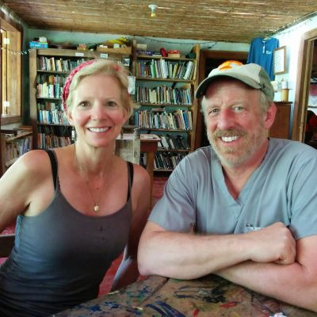
Dr. Greg and Laurie Moore

Program News
Hospitality or Hospital?
An important yet often understressed aspect of Rancho Mastatal is hospitality. People from all over the world come to stay in one of our many beautiful structures and enjoy our surroundings. We host several workshops from Natural Building to Wilderness First Responder (you can see more of the classes offered at our websitehere) that attract an eclectic, caring, open-minded clientele. Almost all of our visitors are extremely curious about our system designs as well as our (apprentice) role within the Ranch. I get to meet so many people, I’m loving it!
Due to the fact that we are in the business of hospitality, much of our apprenticeship is taking care of our guests in some way or another. We prepare the meals on the weekends, we answer many questions, we are guides to the waterfall or river, we prep for many of the workshops here, and we harvest much of the food eaten. In exchange we get new perspectives and good company.
Our guests so far have been such a pleasure. We have even had a couple of people help us by digging ditches, building cob walls, and dismantling garden beds.
The last group that we had here came for a workshop run by the company Aerie Backcountry Medicine whose headquarters are in Montana quite close to my home in the Swan Valley. They brought great energy, from youthful silliness to genuine thoughtfulness. The workshop was for their Wilderness EMT certification as well as a handful of other certificates from swift water rescue to national GPS navigation.
During the last week that they were here, Aerie’s medical director, Dr. Greg Moore, and his wife Laurie joined the group. Dr. Moore teaches the students about various aspects of medicine before they set up a clinic in our community center and perform house visits in the nearby town of Zapaton. They treat the locals for free. The supplies come from donations. Seeing this generosity given so freely to a community that I am growing to love warms my heart.
I asked Dr. Moore how it all started and he explained, “It was a process of evolution”, originally locals would hear about the doctor being in town and come to the Ranch for medical questions or help. He said, “We were treating people here on the front porch”. Then they came to the decision to do a free clinic in the community each year and have the Aerie students take vitals and do the initial intakes with the patients. That way they could teach as well as give back to the community.
I asked him how it made him feel, doing such a great thing for the community. He responded, “Its gratifying to give back to the community here. The people are so friendly and grateful. Its better than any other reward I can think of.”
I did not have time to interview the owner of the company Dave but I can say that from an outside perspective that his life and that of his family is interesting and I'm hoping that down the line I will have time to interview him.
The training that Aerie provides for First Responder and Wilderness EMTs is very much needed. Anytime someone in the community is hurt, the first call goes to the Ranch and the second to the paramedics (if needed) in the town of Puriscal (about 2 1/2 hours away by bus). Since I have been here we had someone break their ankle at the Ranch playing basket ball, a couple sprains/strains, an incident where a man had a car drop on top of him (he was working underneath it), a bicycle accident, and just a few days ago a local 11 year old boy stepped on a nail which went in very deep. In each instance the Ranch was called first for help. Last year there were two apprentice injuries - a broken leg and someone with a severed artery in their forearm. If it hadn't been for the training Aerie provided to the team at Rancho Mastatal the person who severed their artery might have been in much rougher shape today than he is.
The gravity of my situation as a caretaker here during the rainy season is becoming clear. This Ranch is a large part of this tiny community and provides first aid care, jobs to the locals, contributiions to the economy by hosting small to large groups of visitors, and lastly by buying as many local goods as possible. The fact that the other apprentices and I will be responsible for the running of such an important hub while the core group is gone is both terrifying and exciting.
Here's to good thoughts and energy for the rest of the year. May there be no more accidents or injuries.
By Mariah Albertus
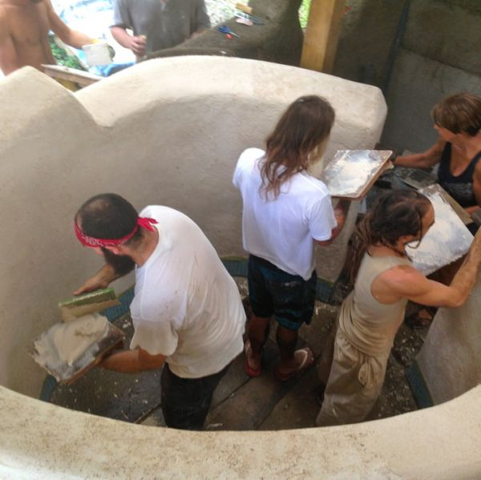
Tadelakting

Building
Lime
Lime has been used for centuries as a building material. The Romans used lime as mortar in their stonework and they also used something called hydraulic lime which is harder and sets faster than normal lime. Hydraulic limes can set under water and have a higher compressive strength, however it is more complicated to manufacture. Lime is a great natural material to use as it is made from limestone which is one of the most abundant stones on our planet. In Costa Rica there are several lime kilns that are relatively close to us from which we can source our lime. Lime is considered a more environmentally friendly material than its successor Portland cement.
Portland cement has pretty much replaced lime in a lot of modern applications both as a mortar and a render/plaster. Lime is still the major ingredient in Portland cement along with some other ingredients, however whereas Lime has to be heated to around 800°C, Portland cement needs to be heated to around 1,300°C.
In order to process limestone into a usable material it has to undergo several stages. This is generally referred to as the lime cycle. Lime is heated to around 800°C in the lime kilns. During this process of "burning" the limestone (CaCO3) is converted into quicklime (CaO) and carbon dioxide (CO2). At this stage the quicklime is extremely volatile and has to be slaked (add excess water). This converts it to calcium hydroxide (CaOH) which is now a workable material. At this stage it can be applied to buildings in the form of a plaster. As the plaster sets on the wall it begins to carbonate and re-absorbs the carbon dioxide that was removed in the burning process as it slowly begins to convert back into CaCO3.
At the Ranch we originally bought our lime from a kiln outside of San Jose. At that time TIM and ROBIN bought the lime in its quicklime form and slaked it themselves. This process is dangerous and creates a huge amount of heat as the quicklime reacts with the water. This year we were able to make our first big order of hydrated lime from another lime kiln in the south of the country. As the lime had already been hydrated it was a bit more friendly to work with. However, we still had to spend hours and hours sifting all the sacks to give us a really fine lime that we could then soak in our barrels. With the help of some technology we blended the sifted hydrated lime into the barrel which created a really nice smooth lime putty. We will now leave it to soak for at least six months before using it.
Traditionally in Europe lime was left to sit for a number of years with the workability of the material increasing with age. To this day it is still common to be able to buy lime putty which has been aged, with the older putty commanding higher prices. In the US Type S hydrated lime is sold and we are told by our colleagues up north that it is a fantastic product to work with and has excellent plasticity and workability after only 24 hours soaking.
In 2016 we expect the lime revolution to continue with further re-plastering of old buildings and new additions being added all the time, high on the priority list will be the newly framed Foodsmithery and Scott and Lauras cabin!!
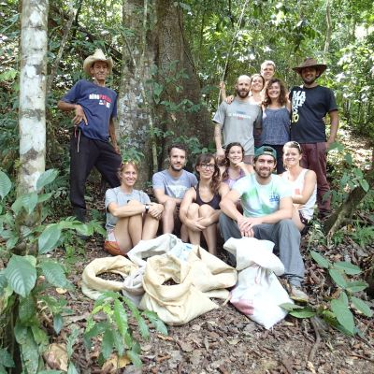
Ojoche Harvest

Farm
Patterns for Experiential Learning
How do we learn? When we engage with new information, what enhances or inhibits our ability to move it from our short-term working memory to our long-term reference memory? Each individual learns in different ways: visual, auditory, tactile, etc, but at the heart of all these mechanisms lie a few shared roots. The power to tap into these roots of learning is what makes it possible to turn information into true understanding and wisdom over time.
We have all used a tool - a keyboard, chisel, knife, guitar - until it literally feels like an extension of our body. The understanding of that usage is now built into our reference memory. No one has to remind us how to play an F chord, nor do we have to consider where to place our fingers. This is the sphere of learning we should strive for in our most crucial endeavors, such as growing our own food or constructing our homes.
A Case Study: Rancho Mastatal Sustainability Education Center
It is with these constructs in mind that we reflect on and examine the role of learning within Rancho Mastatal Sustainability Education Center as a successful permaculture education model. Located in rural Costa Rica, and operating since 2001, an overview of the project can be seen here.
Fifteen years ago, Rancho Mastatal began building its infrastructure with the help of short-term volunteers and students who benefited from their experience in an exciting and dynamic community. Today the Ranch's programming has successfully evolved to offer both long and short-term learning opportunities. As this process unfolded, the core team at the Ranch began to pull apart the variations of short and long-term learning by examining the questions: How do we teach so students leave inspired? And how do we teach so students deeply learn?
This evolution and inquiry is not unique to the Ranch. Many of our friends and colleagues with similar education programs have also transitioned or are in the process of transitioning from short-term to long-term or short-long combination models. This progression is a natural evolution for educational programs that grow from the ground up; are small enough to adapt quickly; and have the resilience to adjust to the type of transformation that an adaptive model entails. Understanding what your educational program can provide as well as what it requires from participants is the fulcrum point for forward momentum.
Short and Long Term Learning Opportunities
Early in the project the Ranch was in need of unskilled labor for building initial infrastructure. Mixing cob, hauling wood, and sanding furniture were common simple tasks. Much of the work was self-directed with guidance from outside course instructors. Many of the tasks could be learned and mastered speedily. The Ranch benefited from this labor, and the volunteers benefited from the excitement and spark of being able to participate in something new. It was a conducive surrounding for volunteers staying a minimum of three weeks.
As the campus and systems grew and matured, it became unmistakable that the minimum stay needed to increase. With beautiful infrastructure and interwoven agriculture systems, Ranch instructors were able to engage participants with a much deeper understanding and skill base. However, it also took more time to teach participants the context that would allow them to be good decision makers in their tasks. A three-month internship was defined and the same process continued, until once again there was an acknowledgment that as the Ranch matured it took individuals longer and longer to become part of its ecosystem. Today, in order to furnish our site's needs, our programs are highlighted by a year-long apprenticeship and a four-month Natural Building Certificate.
Short-term learning opportunities can give participants an introduction to new ideas, the experience of a new place and people, and the igniting spark of inspiration. Intensive short-term programs also deliver substantial information and valuable alliances and networks. These are good things, necessary things, and form a foundation for expansion of permaculture as a global design system. And as we move forward with this expansion, there is increasingly room for longer term learning opportunities which give participants the repetition and experience which foster continued deep learning.
A one-week volunteer cannot translate the intricacies of the Ranch's current food system. From the design and layout of orchards to maintenance regimes to harvest and food processing schedules - these are complex systems. They require time to engage with and understand. Yet they all began with humble foundations built in large part by short-term volunteers over many years. This process of transition and the ability to adapt to changing needs as your program grows (and offer new and different opportunities that your program can successfully deliver) is becoming an essential part of permaculture education programs worldwide.
A Pattern Language for Experiential Learning
While much of this has been a natural progression over a decade and a half of growth, some of this change was also due to the inherent limitations of a two-week natural building or permaculture design course. This style of course provides tremendous value through inspiration, information, and introduction to a new topic, but then often ends there, without support for continuing practice. After years of development, the core team at the Ranch found ourselves with an opportunity to give learners an additional focus on practice and understanding of systems building from “foundation to roofing” through experiential practice. We found that practice was the crucial catalyst that transformed our participants' inspiration, idealism, and new skills, into reality.
The Ranch greatly values and adheres to the principles of experiential learning. Reading or learning about how to do something is a useful tool, but unless you practice what you have learned, it remains a tool unused. Our pattern language for experiential learning is based on the concepts below.
1. Build solid foundations. Complex systems are built upon solid foundations of simple, humble, tasks -- you have to learn to sharpen your chisel before you can build a timber framed house. After time you may be surprised when you step away from your “simple” tasks and find you have already built something complex.
2. Recognize learning patterns. Our program is designed to follow a sequential learning pattern of 1) learning; 2) practicing; 3) teaching; and 4) managing. Each stage of this pattern will challenge and enforce the depth of your skill set. Be prepared to transition your skills into new settings and levels of understanding.
3. Own your skills. Learn something deeply enough to take it with you when you go, not just use while you are here. Ask yourself frequently, what skills do I own now? What skills do I want to own by the time I leave?
4. Value direct engagement. The Ranch's experiential education programs are based on direct engagement with the physical world. We believe you can't truly learn how to plant a tree without actually planting it. Remember that the skills you develop will be embedded in direct engagement with the Ranch's functioning systems.
5. Find the teachable moments. Learning is everywhere, and it's often most effective in the field. Your instructors will pass on new skills and information at times when they are not officially “teaching”. Take time each day to reflect on moments when you learned something new.
6. Learn to fail better. Not everything will go right the first time, or the second. Challenge yourself to recognize failures as opportunities to learn. As you practice new skills, practice them well - don't repeat patterns that don't give you the result you want.
7. Create solutions. In the face of any challenge, you have the power to create solutions. Community living and experiential education are sculpted by individuals' and groups' ability to see themselves as solution builders.
8. Be a part of the whole. The Ranch facilities were built by a network of thousands of people who contributed a part of their lives to build something greater than themselves. As an apprentice you become a part of this larger network. What will you leave behind? How will you utilize this network as you move forward?
By focusing on the above in our programs, we invite students to engage and learn deeply.
From Foundation to Roof - Next Steps
The word “apprenticeship” connotes a graduation to a next level such as a journeyman. The end of our year-long apprenticeship and four month Natural Building Certificate is merely the beginning of a participant's journey. They have transplanted vast amounts of information from their working memory to their reference memory, forming the cornerstones of knowledge and understanding. The next step after this is crucial in shaping this opportunity into a career or livelihood.
The Ranch's long-term goal is to render these next steps through our design/build consulting business. Our team offers permaculture design services for clients, such as developing conceptual site plans or providing advice for construction techniques in the humid tropics. We often do not have the capacity to direct the implementation of this work. Our vision is to connect our apprentices with these projects and bring them on board to manage the implementation. This would result in real-world, real-time experience, challenges, and compensation. It would cement the deep learning built upon the groundwork of our programs. Undoubtedly, we are a number of years away from the finalization of this integration, but with the goal in mind and the pattern language of learning in place, this can become reality.
This type of learning and real world experience is required in the permaculture sphere. We must become more than course junkies, forum readers, and facebook friends. We can take these patterns of experiential learning and apply them across disciplines to encourage a profound learning that will transform inspiration and idealism into reality on both a small and large scale.
We need permaculture education programs that engage learners from all perspectives - both short and long-term, and in as many different ways as possible.
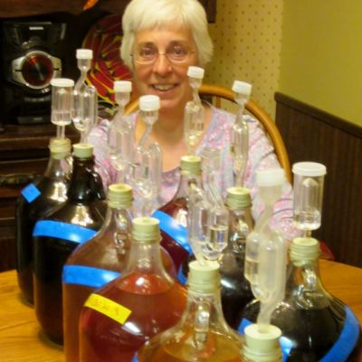
Air Locks Galore

Food
What Next?
One of the most frequent questions apprentices and course participants ask as they near the end of their stay at the Ranch is “What next?”. After spending an entire year―or even just a few days―learning new skills in food preservation, recipe creation, brewing, fermenting, spice and oil preparation, butchering, cheese and yogurt making, local flour production, medicine making, and much more, what do you do with your new skills?
The answer: anything you can imagine. Once you learn a skill and practice it, you own it. It’s your skill to have for the rest of your life--yours to keep, to travel with, to share. The best part about it is that no matter how much you use that skill, practice it, share it, and transform it, it will only increase in value. What a good investment!
In this world of Google and YouTube, we have access to exponentially more information than we can use in a lifetime. There is a lot we can learn from reading and accessing two dimensional resources. But it’s not enough to just read and watch. We have to do these skills to bring them to life, to understand them and own them. It is the experience of learning through practice and application that gives the Ranch’s apprentices and course participants true ownership of the skills they learn.
The skills learned at the ranch are yours to have and keep, but just like any investment you need to manage them in order to realize the potential of their return. The following are a few tips about simple ways you can continue to increase the value of the new skills you now own, and help answer the question, “What next?”.
1. Keep practicing.
Knowing about food skills without practicing them won’t do you jack squat when you’re hungry. It will be different practicing your food skills in a new place. You may have to adapt or source new local ingredients. You may need to scour thrift stores or make your own special or simple tools. In the world of fermentation, you will need to rely on your experience to assess temperature differences and how they affect flavor and preservation. But practice, you can! Practice is the crucial catalyst that transforms inspiration and idealism into reality.
2. Connect with others.
One of the best parts of staying at the Ranch is connecting with a wide network of people who are engaged in transforming the world in positive ways. These are people who work or live at the ranch, who teach courses, who came for a class, a visit or an apprenticeship. Each individual brings their own amazing network of people who are building solutions for the challenges we face. You can keep connected in the two dimensional world with the Ranch’s facebook page , or in three dimensions by reuniting with other Ranchers and their networks. Over the past several years, a great place to reconnect has been at Round the Bend Farm: A Center for Restorative Community in Massachusetts, where former Ranch interns DESA and GEOFF work their magic. Round the Bend has attracted cameos from dozens of Ranch Alumni over the years, and has traditionally been the meeting spot for all those heading to the annual Connecting For Change Conference each October.
3. Learn more.
Your skills are a foundation for more learning. Continue to build by reading, watching, and participating in new classes and workshops. Learn from neighbors, professionals, and friends.
4. Teach your friends, including your mom.
Your friends, including your mom, will probably be extremely curious about what you were doing in Costa Rica! Showing and sharing your new skills will not only help them understand more about your experience, but there are added benefits! Last year I taught my mom how to make wild fruit meads, and this year I came home to a selection of mom-made aged meads crafted with wild raspberries and local herbs. (See photo!)
5. Create something new!
Maybe it’s a new recipe. A tool. A farm. A livelihood. A book. A social movement. A puppet show. I don’t know, only you can know what it is you will do with the skills you own. There is no limit to the possibilities for what you can create.
By Laura Killingbeck
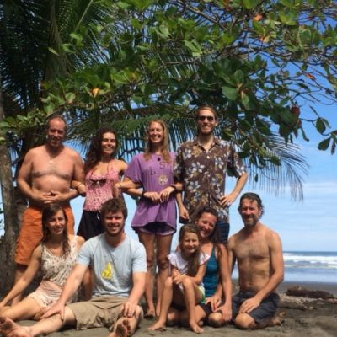
Crew at Beach

Community
Life as an Ex-Pat
Robin and I have lived in Costa Rica as ex-pats for the last 14 years. We also lived and traveled in South America for 3 years in the 90s, mostly in Uruguay where we met and worked as Peace Corps Volunteers. We've spent about 70% of our post-university lives in Latin America. When I looked at that number a while back, I must admit that it caught me a bit offguard as I couldn't pinpoint ever saying to myself, “to hell with life in the States, I'm going to live elsewhere”. Our move from Seattle to Central America (a multiple week trek through the Western States, Mexico, Guatemala, El Salvador, Honduras and Nicaragua in our two Toyotas) all those years ago may have been as much a function of our more spontaneous side winning out in that “moment” as a conscientious need to engage with this world in a meaningful way that would meet our personal and professional goals at the time and in a way that would be within our budget to execute. Regardless of the specifics as to the why or how we set out for a new life outside of our country of birth, since then, the days, months and years have rolled on by. Since Halloween day in 2001, our adopted home has been a small, rural community on the edge of the jungle in Central America. Our living situation in Mastatal has resulted in countless challenges, innumerous inspirations, and a boatload of experiences that have helped to make us into the people that we are today. In many ways, it's been a whirlwind, though in every possible way, I feel more awake, healthy and prepared than before embarking on our eventful, international adventure. Over the past decade and a half we've started a fulfilling and demanding sustainability based business; brought into this world and raised a beautiful little girl; expanded our network of family, supporters and friends tenfold; learned an astounding array of hard and soft skills; and grown as a couple, professionals and family in unimaginable ways. Through all of this, what sticks out the most for me at times, is the level of dedication and energy that we've needed to invest as members of our community to feel fully integrated. Moving to a country where the language, culture and climate are so different to what we experienced up until the move has tested us in a variety of ways both expected and unexpected. Given our relative priveleged situation as visitors from a wealthier nation, I am ever mindful of our impact on our adopted community. Every decision that we make necessitates a process that involves making determinations about how we might affect others in our town. This might not seem out of the ordinary to many, but as North Americans living abroad, each of our actions have been magnified by the reality that we're operating daily on somebody else's turf that we share no prior history with. Even though I participate in local sports; manage a high-profile business that employs a number of locals; willingly engage in the not always pretty everyday political and social life of a tiny, rural community; and provide a plethora of services for the community, the work to fully assimilate is far from complete. There's some metaphorical bridge that I've only been able to partially cross since our move to Costa Rica. At times I feel as if I'm nearing the other side and at other times like I'm just taking my first steps across. Nevertheless, since the birth of Sole 7 years ago, my journey to cross the bridge has taken on a new feel. Babies and kids have a way of breaking down barriers and building bridges that adults don't. Her arrival has been a blessing in so many ways, but her ability to help create a larger sense of home for me in Mastatal has been especially welcomed and embraced. With Sole, Mastatal has become more than just the community that Robin and I decided to call home; it is her home.
Given Costa Rica's long, sometimes complicated history living amongst US born expats, I wonder how being a transplant here might differ than in other parts of the world. It's a question that leads me to sometimes strange and uncomfortable thoughts and has me occassionally questioning where I physically belong in this world. These thoughts increasingly rise to the surface while we're enjoying family, friends and temperate forests up north and making decisions on how best to educate our dual citizen, bilingual daughter, and how to invest our time and energy during these more tranquil months stateside. The reality of having two lives, in two different countries, is a true privelege that has allowed us to gain a unique perspective on this world and how it works. That said, with age and parenthood, arise questions of stability, family connections, long-term health and education, and legacy.
Each year the Ranch becomes a more stable, resilient entity that we hope will continue to positively impact our small community for decades to come. Simultaneously, it increasingly becomes the manifestation of the type of community that we dream can exist elsewhere in this world. With the new organizational structures that we're putting into place, I'm hopeful that our project's evolution can create a positive, lasting impact while demonstrating that this type of business and its associated community are relevant and possible in today's world. With Sole reaching middle school age in 5 years, we'll have an enormous decision to make by 2020. The middle school in Mastatal, in its current state, is not the ideal learning environment for our daughter though sending her to school outside of town elsewhere in-country seems unimaginable to us right now. Homeschooling and middle school in the States are both on the table, and Sole will of course have more to say about this decision as she gets older, wiser and bolder. Our current reality has her splitting time between Mastatal's elementary school and a wonderful homeschool program that Robin's developed and teaches during our stays in the States. How it unfolds moving forward with governmental institutions having more of a say each year how we educate our daughter is a bit of an unknown. It becomes a lot to think about but we're confident that with an improving life and business structure and a little faith that it will all work itself out over time.
Life as an expat has been a blessing on countless levels and our connection to Mastatal will undoubtedly continue to be the centerpiece of our world for years to come. Nevertheless, the specifics on how our expat lives unfold is still a bit difficult for us to predict. In the interim, we'll continue enjoying the benefits of life in Central America and enjoy our lovely visits each year to reconnect with family and friends in the Northeast. Thanks to all of you for taking part in this sometimes wild ride.
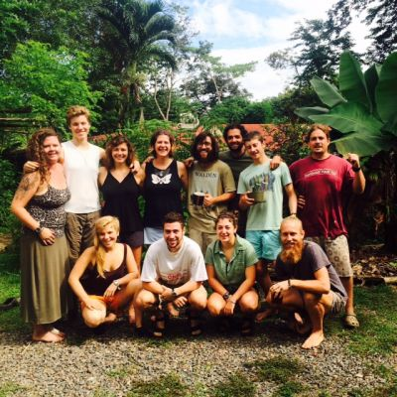
2015 Apprentice Crew

Apprentice/Guest Contribution
2015 Caretaking Apprentices
Meet our spectacular grop of 2015 Caretaking Apprentices.
Name: Dorothy Farrell (Doro!)
Where Ya From: Brooklyn NY
Strongest Area Of Interest At The Ranch: Agroforestry, Landscaping, Botany
Any Secret Skills: Handstands, Free Styling
3 Essentials To Bring To The Jungle: Hammock, Nug Net P-Style
Hobbies: Writing, Painting, Hiking
A Title For Your Dream Job:Garden Architect
Favorite Spanish Word: Guacala!- Disgusting!
Name: Mark Ferguson Heisey
Where Ya From: Lancaster, Pennsylvania
Strongest Area Of Interest At The Ranch: Making great soap.
Any Secret Skills: French Braids.
3 Essentials To Bring To The Jungle: Hat, Boots, 2 of everything (because 1 is always wet)
Hobbies: Playing folk music, watching good movies, reading good books
A Title For Your Dream Job: Golden Age Pirate Captain
Favorite Spanish Word: Aguantar
Name: Jamie Neal-Action Jackson
Where Ya From: Massachusetts and Vermont
Strongest Area Of Interest At The Ranch: The BioD and methane cooker, lovin’ those closed loop systems! I also enjoy lifting heavy things and running art class for the local kids at the library every Thursday.
Secret Skills: Eating copious amounts of meat, writing and performing spoken word poetry
3 Essentials To Bring To The Jungle: My P-Style (Thanks Laura K!), Notebooks, High Socks
Hobbies: Sailing, Reading, Learning Spanish, Gardening, Causing Mischief
A Title For Your Dream Job: Ship Builder of and First Mate on a Golden Age Pirate Ship
Favorite Spanish Word: Picante- Spicy
Name: Jake Evans
Where Ya From: UK
Strongest Area Of Interest At The Ranch: Agroforestry, Natural Building
Any Secret Skills: Tying Knots
3 Essentials To Bring To The Jungle: Machete, Long Socks, Buena Onda
Hobbies: Yoga, Rock Climbing, Permaculture, Surfing
A Title For Your Dream Job: Head Agroforester
Favorite Spanish Word: Dale- OK
Name: Carolina Santillan
Where Ya From: El Bolson, Argentina
Strongest Area Of Interest At The Ranch: Food, Natural Building, Speaking English
Any Secret Skills: Dancing, Making Bracelets
3 Essentials To Bring To The Jungle: Hat, Boots, Mate’ To Drink
Hobbies: Dance, Listen To Music, Sew, Biking
A Title For Your Dream Job: That’s the situation, I have no idea!
Favorite Spanish Word: Tengo Fiaca- I’m lazy
Name: Jacob Porter
Where Ya From: Bolivia
Strongest Area Of Interest At The Ranch: Fermentation, and BioD
Any Secret Skills: Reading Fairy Tales Aloud
3 Essentials To Bring To The Jungle: Hammock, Reading Material, Mogi-Net
Hobbies: Reading/learning, walking or biking as a method of exploring wherever I am living.
A Title For Your Dream Job: Loafer
Favorite Spanish Word: lluvia- rain
Name: Willy Rees
Where Ya From: Pilot Mountain, NC
Strongest Area Of Interest At The Ranch: Natural Building, Woodworking
Any Secret Skills: I can see into the future.
3 Essentials To Bring To The Jungle: Stamina, Patience, Gold Bond
Hobbies: Arts & Crafts, Music, Reading, Hiking
A Title For Your Dream Job: Craftsman
Favorite Spanish Word: Despiche- clusterfu*k
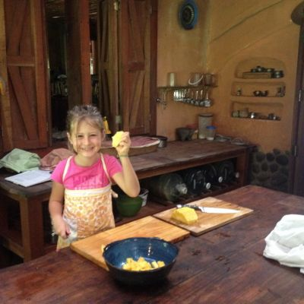
Sole in the Kitchen

Kitchen
Tomato And Pecorino Tarte Tatin
This delectable recipe comes from a fabulous book Forgotten Skills of Cooking by Dariana Allen. Upon coming back to the Northeast we have been swimming in red, ripe, delicious tomatoes. I came across this recipe and had to give it a go. Sole and I made it together and it is simple yet great. It got a double thumbs up from everyone at the table. I served it with a wilted spinach salad, yummmmm...
Tomato And Pecorino Tarte Tatin with Savory Shortcrust Pastry (recipe for pastry follows below)
Ingredients:
- 1 lb. ripe tomatoes, salted and sliced (these are to be arranged in a circle)
- 4 tablespoons butter
- 12 oz. onion, chopped
- red chile
- 2 garlic cloves, crushed
- 2 lb. very ripe tomatoes, peeled, seeded and chopped (I didn't peel mine and it was fine, this is for the filling)
- salt, freshly ground black pepper, and a little sugar (or honey)
- 8 fresh basil leaves, torn
- 1/2 cup (or more!) pecorino cheese, grated
- 9 in. ceramic pie pan
- parchment paper and a little melted butter
Directions:
Preheat the oven to 375 degrees F.
First, make the pastry.
Basic Shortcrust Pastry (Savory)
The aim is to make a crisp, crumbly, but not brittle pastry. Makes enough pastry to line a 9in tart pan.
- 1 1/2 cups all-purpose flour
- 6 tablespoons cold butter
- pinch of salt
- beaten egg or water (to bind)
Sift the flour and salt ino a large bowl. Cut the butter into cubes, toss into the flour, and then rub in with your fingertips (Sole loved doing this). Keep everything as cool as possible; if the fat is allowed to melt, the finished pastry may be tough. When the mixture looks like coarse bread crumbs, stop.
Beat the egg and add some cold water. Using a fork to stir, add just enough liquid to bring the pastry together, then discard the fork and collect it into a ball with your hands, this way you can judge more accurately if you need a few more drops of liquid. Although rather damp pastry is easier to handle and roll out, the resulting crust can be tough and may well shrink out of shape as the water evaporates in the oven. The drier and more difficult-to-handle pastry will give a crisper, shorter crust.
Flatten it into a round, wrap in plastic wrap, and leave to rest in the fridge for at least 15 minutes. This will make the pastry much less elastic and easier to roll.
Peel, seed, and slice the 1lb of tomatoes. Sprinkle with salt and leave to drain in a nylon sieve for 10-15 minutes.
Now back to the filling..
Melt the butter in a wide saute pan, add the onion, chile and garlic. Cook until soft and just beginning to caramelize. Add the chopped tomatoes and season well with salt, freshly ground pepper, and a little sugar (or honey). Simmer until reduced to a thickish paste. Add the torn basil leaves. Taste and correct the seasoning.
Line the base of a ceramic quiche or pie pan with a circle of parchment paper. Brush generously with melted butter. Arrange the drained tomato slices in an overlapping pattern in concentric circles over the base of the pan. Spread the cooked filling evenly over the tomato slices. Scatter with the pecorino cheese. Top with a circle of savory shortcrust pastry.
Bake in the oven (on a cookie sheet to catch drippings) until the pastry is golden brown and cooked through. Remove and leave to cool a little before inverting the pie onto a plate and removing the pie pan and the parchment paper. Serve warm or at room temperature with a good green salad.
Buen Provecho!
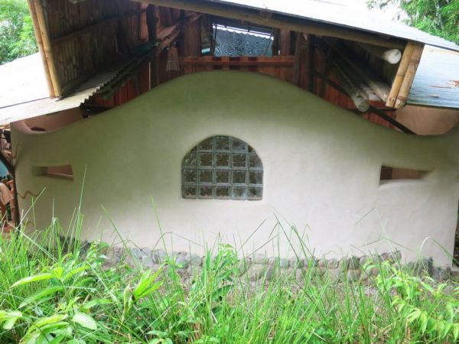
Hankey Exterior Wall

Inspirational Impressions
Wendell
“We have lived our lives by the assumption that what was good for us would be good for the world. We have been wrong. We must change our lives so that it will be possible to live by the contrary assumption, that what is good for the world will be good for us. And that requires that we make the effort to know the world and learn what is good for it.”
― Wendell Berry
Abrazos,
The Ranch Crew

