Rancho Mastatal Updates
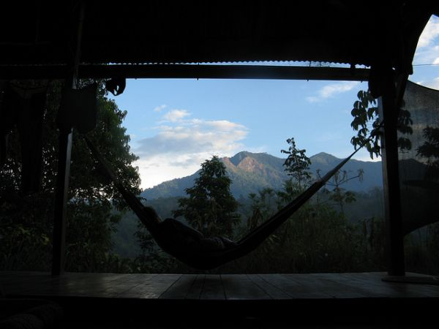
Hammock time at the Cork

July August September 2012
We're closing in on the end of our 11th year in Mastatal. It's been one of our most fulfilling annums to date and with the arrival of the heaviest rains comes the expected tired body and mind. We're looking forward to a little respite from our busy lives in Mastatal as we think about a bit of rest and reconnecting with family and stateside friends. We had a little slice of our US home come to us at the end of this season with heartwarming visits from Robin's mom and sister and Tim's mom, sister, brother-in-law and niece. It was a nice reminder of what we're soon to go back to but also reminds us of all that we need to get done before our flight to Newark and UNCLE AL in August. Robin's morning has begun to take on a bit of a routine with Sole's daily and incessant questions about what she'll be ordering from the flight attendant and reminders of where the bathroom is located on the big plane. As might be anticipated, we have a long list of to-dos to tick off in the coming weeks, from planting the last of our trees for the year, to imparting a lot of information and wisdom to the caretaking crew that will be watching the Ranch in our absence. We have the great luxury of having two veterans at the helm this year. SCOTT and LAURA, with whom we've been exploring partnership arrangements, will be leading the gringo-side of the “Ranch show” this fall. They'll be assisted by a relatively new crew of interns and of course our amazing tico staff. They'll have their hands full though we'll be encouraging them to slow down a bit and enjoy more indoor, contemplative and meditative activities during the rainier months. Our annual Permaculture Design Course (PDC) went exceedingly well again this year with 17 students and Jorge doing his amazing translation act. This course has become an annual source of inspiration and we're indebted to CHRIS SHANKS for his knowledge, openness and teaching abilities. He'll be returning to the Ranch this fall to teach the first course of our new Applied Permaculture Series on Orchard Establishment in the Tropics. Now that we're hosting more in-house classes, courses and workshops, we greatly appreciate you helping us spread the word about our offerings. Please share postings on your listservs and Facebook pages and encourage friends and family to sign up for our newsletter on our Home Page or like us onFacebook. As has become tradition over the past few years, we wrapped up our season with another great visit from ANGELA and her students from Hawaii Pacific University. Angela has been one of our most ardent supporters during the past decade and another individual that we owe so much to. Thank you to everyone reading this for making the Ranch what it is and for your backing and advocacy. The remainder of our newsletters for the year will reach you via the United States where we hope to connect with many of you this fall. Enjoy.
This month's update includes:
RM Program News: Many Hands, Many Trees
Building Report: Our New Busy Builders
Conservation Update: The Mastate Tree
Farm Facts: Permaculture Poetry
Community Stories: Community Nightmare
Intern/Guest Gossip: A Path
Comida Corner: Kettle Corn Popcorn
Fútbol Follies: Offseason
Inspirational Impressions: Twain
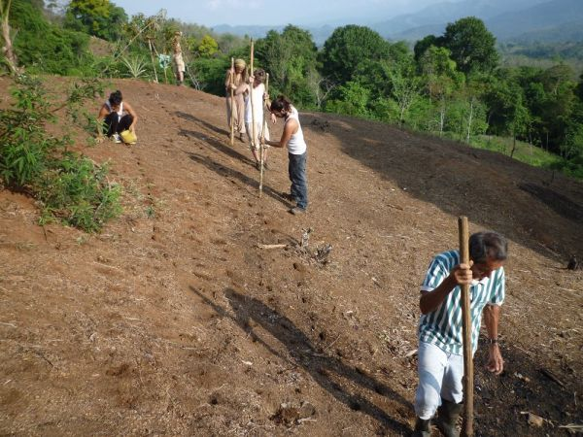
Planting rice in San Miguel

RM Program News: Many Hands, Many Trees
When I left the Ranch 4 months ago, we were just bagging up the 2100thnitrogen fixing tree seed. It took many hands to acquire seeds and bags, gather and mix the proper soil ratio, prep the seeds by soaking, boiling, and scarification, clean and organize the nursery, and fill and plant each and every bag. And still, by the time we left, with all 2100 bags tucked in rows, the work was just beginning.
One of the wonderful things about the tropics is that plants grow fast. The hard part is that plants grow FAST. Within a few weeks many of those seeds had already flung off their coats and were busy unfurling leaves upwards towards the light. So while I was long gone, frolicking among temperate asparagus and hardy scallions in Massachusetts, many more hands were back at the Ranch, transplanting all 2100 baby trees. And not just transplanting—I’m talking on contour here! That means mapping, measuring, flagging, and stacking more functions than you can shake a stick at.
Coming back to the Ranch and seeing all those trees planted on contour in just the way we had dreamed them up months before, blew my mind.
Systems at the Ranch are a lesson in balance in motion. Even the simplest project requires maintenance and use by other people. Houses are built to be lived in, loved in, and cared for by people we will never meet. Trees are planted to bear fruit to feed someone who may not even be born yet. We have faith as we are building these projects that they will be valued, cared for, and enjoyed by people we don’t yet know and mostly likely never will. And as we build, we enjoy the fruits of other people’s labor (thank you RACHEL for the rambutans!), live in beautifully hand built homes, and ride the wheel of tried and true systems that orchestrate community living.
Thank you to many hands and many trees.
By Laura Killingbeck
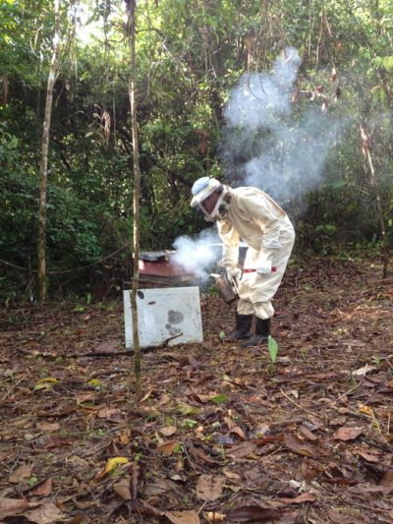
Scott and his bees

Building Report: Our New Busy Builders
The lunch horn blows and I drift into the main house from planting Vetiver down in Ferngully. As I pull up a stool in the pit someone casually tells me that Luis is coming with the bees tomorrow morning. I ponder this statement before responding with a matter of fact nod and grunt of sorts. Bees, OK, I guess one could call that a surprise. Concentrating back to the last conversation with Luis, our Ministry of Agriculture extension agent, I attempt to remember what may have been lost in translation. Pretty darn sure I said I would call when all was ready for the bees. Of course we are in Latin America where plans seem to get washed away in the rains. Six inches in two hours clears the topsoil and your schedule.
We placed an order for bees a few months ago, and had almost given up hope that they would arrive this year. Yet, suddenly, when I feel least prepared they arrive. The list of things that we haven’t prepared rolls through my mind. Vinicio hasn’t finished welding the benches for the hives to sit on. We don’t have a bee suit. We haven’t even cleared the site yet. I wonder how this will play out. I am not one to panic, but I can feel a slight pressure building; it sits uncomfortably between my shoulder blades. Bees are a big step for us, one we have been talking about for years. These are a cross between European and Africanized bees. They can be aggressive and we can’t take any chances with anyone getting stung and having an allergic reaction. Scrunching my brow I am second guessing this decision.
So, I do what I always do when I have a question. I go and talk with Chepo. Thank goodness for Chepo. He reassures me that we don’t need a suit to install the bees and that he can go and start clearing the site. I am counting on his experience working with bees in San Miguel over the last ten years. Reminding myself of this makes me feel more confident. My nerves continue to dissipate as Vinicio wanders by and lets me know that he has just finished the benches for the hives and they are sitting by the workshop. Quintessentially impeccable timing. It is amazing how one can go from a point of stress to tranquilo in a few short moments. My initial fears calmed, I start getting excited as Chepo explains how much honey we can get from these hives. Eachmarca or panel can produce up to 750 ml of honey. We will only have two small boxes to start, each with 6 panels; but that is still a lot of honey! Let the daydreams of Ginger Mead begin!
The next day Luis amazingly arrives on time with two hives stuffed into the back of his truck. A few loose bees have escaped making me wonder about the safety of this whole operation. We gently lay the two hives in our sturdiest wheelbarrows and begin the trek a quarter mile down the trail to the Rio Negro, slowly on the gutted out path, trying not to anger the bees as we bounce over roots and the odd fallen limb. To keep the wheelbarrow balanced I find myself crouched awkwardly close to the hive, heightening my awareness of the bee’s emotions; expressing their displeasure over the roughness of the road. Nevertheless we arrive to the freshly cleared site, set up the hives, and back away quickly as Luis opens them up to Mastatal’s rainforest flowers. And just like that we have bees.
The bees fly out of the small opening with a mix of aggression and caution. But it is a quiet, anticlimactic scene, and it makes me smile. The Ranch population has grown by one species and thousands of individuals in this small moment. Definitely a good decision. In a few days I will don a suit and mask and feed the bees for the first time. The harvest season starts as the rains end for good in January, and needless to say we are looking forward to it.
By Scott Gallant
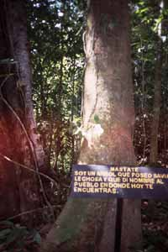
Our namesake — the Mastate tree

Conservation Update: The Mastate Tree
Mastate tree in Mastatal. Mastatal: place of mastate tree.
Meditations on the Mastate tree. During the last decade of hard work, service, learning and inspiration as well as much mirth, we have occasionally wondered about unraveling the mystery of the Mastate tree, for which the community of Mastatal is named. Members of the local populace, with strong command of knowledge of the forest trees claim that is similar to the Ojoche tree, a tree of great interest to Permaculturalists.
Interest in the Ojoche or Mayan Bread nut or Ramon or AKA (Brosimum alicastrum) of the mulberry family, Moraceae stems from its great utility as a tree crop. Tree crops are foods that act as ‘staves of life’ or ‘fill our bellies at the end of the day.’ They can compliment or even replace staple grains. Their promotion as elements of reforestation is a key strategy for reforestation as the trees planted can still provide for human’s basic food needs while restoring forest and sequestering carbon. The nutrient content of foods from trees is often greater than grains. These crops to name a few come from trees like: chestnut, hickory, breadfruit, acorn, walnut, hazelnut, buartnut, jackfruit and sapote to name a few.
Our interest in Ojoche as Permaculturalists has been profound especially in Central America because it is both native and very productive. Furthermore the tree produces a high protein leaf very suitable for animal forage. The tree coppices well and can be maintained in this way in agro-silvo-pastoral systems. The tree can also be allowed to grow as an orchard nut tree with pruning or left to grow large for a zone 4 near forest sized tree. It can reach over 30m of height and can be quite broad as well, the bark is smooth, the leaf obvo-lanceolate, glossy and green. The seed the tree produces is a tree crop. It can be eaten fresh or toasted and ground into flour, mixed with wheat to reduce wheat usage or nearly eliminate it. It is dark roasted into a chocolate or coffee substitute. It is sold in Nicaragua at small scale as a breakfast cereal served hot as well as great non-corn pinol grain for Nicaragua’s national drink.
Having served as a principal consultant and permaculture instructor at the Ranch for 2 years I have been actively promoting the tree. Unbeknownst to me though until recently was the ‘Mastate tree mystery,’ AKA the head fracking we experience in tree ID between Spanish, English common names, vestigial indigenous words and botanical Latin.
So as it goes, Simon Evers and I were on our way down to the river after the 3rdannual PDC at the Ranch, the day after being in the ‘zone’ (calzoned ϑ) thanks to Ranch staff and treated to some fine music and dance, we were accompanied by a group of folks a bit ‘rough around the edges’ after the previous evenings. Only the river could cure their ailments. Simon and I were sauntering along, I saw a tree with extremely smooth bark, remarked to him ‘what tree is that,’ and he said ‘That is the Mastate tree,’ I looked up and peered at the leaves. I said ‘looks helluva a lot like Ojoche’ Simon said ‘Local people say they are hard to tell apart’ to which I answer ‘I bet they are botanically the same species and that the differences perceived locally are more environmental in nature or place based variances.’ After a great afternoon in the curative waters I sidled up to my computer and accessed my ‘Nombres Comunes de America Central’ book written by CATIE and Oxford University. Very clearly stated and the only synonym, Mastate tree= Brosimum alicastrum= Ojoche tree. Mystery solved.
What does this tell us?? (Important part)
It validates our initial design guidelines: Plant tree crops and plant mastate/ojoche. It reinforces other design guidelines: plant related species to ojoche like: breadfruit, jackfruit, marang, champedak etc… We call this ‘seeing across family’ it allows us to consider employing edible species from other parts of the world that are related botanically to useful native trees. Such a group or as we say in permaculture, guild of tree crops would provide for most of our belly filling needs along with pejibaye and coconuts.
This important tree crop, one so important that the Tico settlers that came here called this place ‘Mastatal’ or ‘Place of the Ojoche’ or perhaps ‘Place of the Ojoche in great number.’ Furthermore this name ‘Latinized’ by Ticos probably came from original indigenous naming. We should ask the folks at Zapaton.
This tree crop could and should be a rallying cry for an effort not just from Mastatal but regionally to gradually phase out cattle and reintroduce useful natives and multi-use allies to create an agriculture for the region that gives back instead of slowly destroying the region, its economy and without CR subsidies, potentially its people.
There are existing efforts in Central America to promote this tree crop once again. Visit the ‘Mayan Nut Institute’ (http://mayanutinstitute.org/ )website for more.
Well, now that we know some facts about this rock star tree let’s collect a boatload of seeds and plant it like mad.
By Chris Shanks
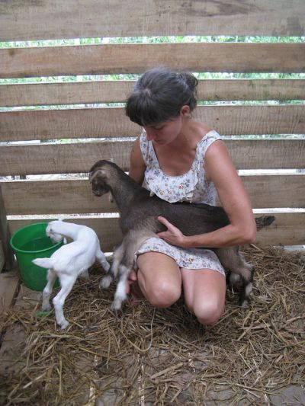
Anne with baby goats
photo by Sam Gibbs

Farm Facts: Permaculture Poetry
The casualty
Of the personality
Persisted throughout the population
All hooked in
The people began
To shift inwards in orientation
And if they looked out
The sirens would shout
Announcing intruders seeking salvation
Entertainment overload
In every abode
Slowly rotted their attention spans and their minds
While their teachers expounded
And information abounded
Actions and skills were quickly left behind
Fruits hung low
But with only poison seeds to sow
The children were served a plate of future starvation
Starvation of sense
And moral pretense
All packaged in a plastic formation
But some seeds did sprout
And purged the toxins out
Shot down roots and grew towards the sun
In its glory they basked
And with a job they were tasked
To spread a message to everyone
Observe and learn
To the natural world you should turn
To be your guide and your muse
Patterns provide paths
On nature’s behalf
Take note and her designs you may use
Heal and grow
Regenerate and sow
Fill gaps when opportunities arise
Harness energy from the sun
For this is how life is begun
And always be prepared for a surprise
Work from the edge in
When your projects you begin
To optimize your ecological design
Take walks amongst the trees
And identify the direction of the breeze
Everything around you is definitely a sign
Advance succession
By honing perception
Not tomorrow, do it today
Recreate and revive
Allow the environment to thrive
For action is the best antidote for dismay
Slow, store, sink and catch
On the world’s behalf
And in abundance you will abide
Make plants, rocks, sticks and gravity your staff
Then sit back and enjoy the ride
Build swales,
Ponds and serpentine trails
And remember to optimize the edge
For in life’s confusion
Seek peace in solutions
Help humanity step away from the ledge
THE END
by Tucker Szymkowicz
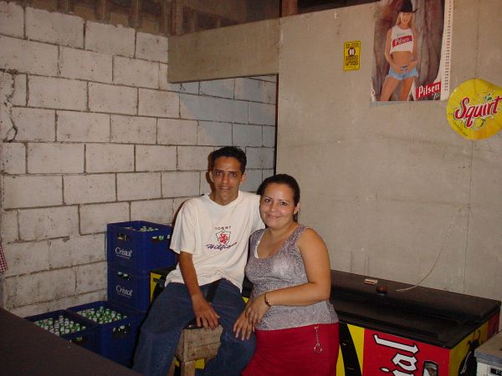

Community Stories: Community Nightmare
An imaginable nightmare has come true for us in Mastatal. An out-of-town businessperson has purchased property that borders the Ranch and near downtown Mastatal and has begun to hold our project hostage via incessant noise and threats of all-night music. The situation has been testing our patience and subsequently building our tolerance. It has forced us to think about an evolving Mastatal and the not-so-embraceable characteristics that growing towns can at times take on. Yes, our little town is maturing. The roads are improving. The phones are more reliable. Businesses are appearing and surviving. And with this has come expected challenges and changes that negatively affect our small population of just over 100 people.
The law in Costa Rica states that there can only be 1 bar for each 300 inhabitants in a community. We have less than 200 full-time residensts in our town but are now faced with the reality of a second cantina. As Chepo says, Costa Rican law is elastic. Who you know and how much you can pay can influence what one is able to do in our adopted country (sound familiar?). The owner of the new business, Alex, has made it abundantly clear that his goals are driven by greed and profit and is willing to push the laws to the limit to assure that he gets what he wants. Trying times are oftentimes the impetus for positive change, but rarely does this come about without some pain along the way. I feel as if everything we've poured our time and energy in to throughout the past decade is at risk. This threat does not stem from poachers, large agribusiness, 5-star hotels or big government but rather from an individual motivated by the crowds he can attract via promises of a nonstop party. The unfortunate placement of the recently opened bar results in an amplified bass reaching numerous houses in town and has the elderly, working class and students alike cringing in their beds. What will come of all of this? It's impossible to know at this early stage. Nevertheless, I do see this issue as an opportunity for our community to come together in ways that it may not when not faced with an issue that catalyzes the majority of our residents. This topic is a sticky one and certainly has two sides. For many young adults and those thirsting for a more “interesting” life, the opening of the new bar is a source of excitement and allure. It promises late night partying, musica bailable, and a haven to hang out with compatriots and visiting foreigners. In an effort to keep sane on those nights when the music just won't stop, I try and remind myself that life could have presented us with an even uglier challenge and that we need to accept that change brings both bounty and blood. As members of our community we can't steer all local policy nor sway regional politics in a direction that always appeases us. We live in a dynamic community filled with differing opinions and small town problems all playing out in front of the greater backdrop of a global situation that at times feels so precipitously perched on the edge. We also reside in a town that's working cohesively to advance innovative agroforestry practices, jointly addressing regional food security and conservation issues, waging an effort to promote a sane model of experiential education, and communally envisioning a region that's focused on sustainabile solutions for our rural communities. These initiatives and others are what provide a high-quality life for most of our residents, most of the time. Even with some annoying treble and bass, Mastatal continues to be an amazing place to work and live and we're honored and blessed to be a part of it.
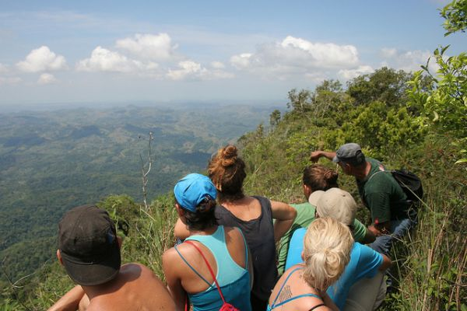
At the top of La Cangreja with Don Mario

Intern/Guest Gossip: A Path
Endless in its possibilities,
A fragile stream of conscious water.
The summit of a far mountain,
A whole life ahead.
The dream, to meet the source of the stream,
To reach the wholeness,
To look above the world,
To find myself
R.A.E. De Amici
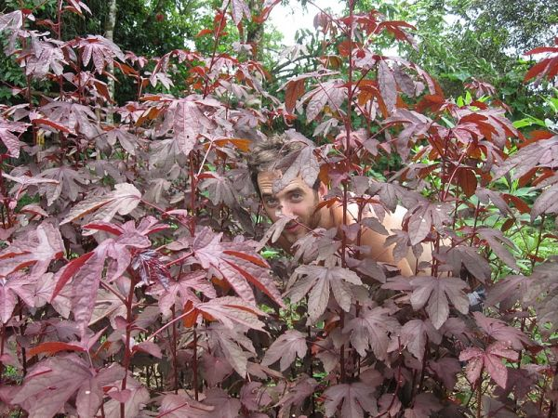
Jacob in the Cranberry Hibiscus

Comida Corner: Kettle Corn Popcorn
Now you don’t have to wait until the state fair rolls around to enjoy this delicious treat.
1/4 cup oil
1/2 cup popcorn kernels
1/4 cup sugar (you can use any kind of sugar, tapa dulce works too!)
Salt and cinnamon to taste
Mix together popcorn kernels and sugar and set aside. Place large pot on burner. Add the oil and 2 or 3 un-sugared kernels. Cover with lid and wait nearby. Once you have heard the kernels pop, that means the oil is now hot. Add the rest of the kernels and sugar, stir quickly with a spoon and recover with lid. Once you hear the kernels begin to pop, use pot holders to pick up the pan being sure to keep a clamp on the lid. Begin shaking the pot around, alternating between swirling, shaking it up and down, and then placing it back on the burner. Keep the pot close to the burner even when shaking. Once popping begins to climax, continue shaking until there is a 1 second interval between pops. Remove from heat immediately. (This may be sooner than you usually remove it when popping regular popcorn, but the sugar will burn if you wait longer than this) Keep the lid on and continue shaking every few seconds until the popping has completely finished. Remove lid carefully, hot steam will rise quickly out of the pan. Pour popcorn into a big bowl and add salt and cinnamon to taste. Buen provecho!
From Kassidy Rogers
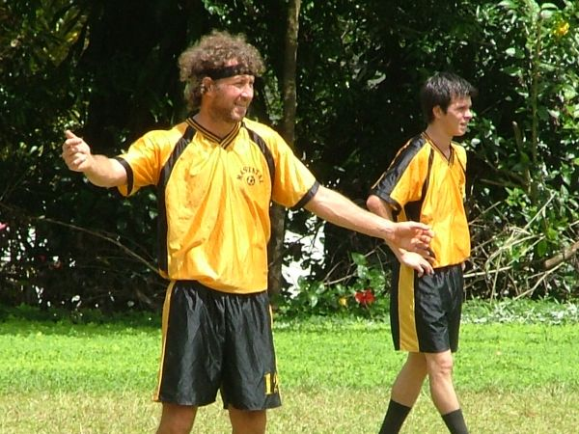
Timo whinin about a bad call

Futbol Follies: Offseason
There's little to report in local soccer news this edition. So here's something to think about until next time.
“The rules of soccer are very simple, basically it is this: if it moves, kick it. If it doesn't move, kick it until it does”.
~Phil Woosnam, 1974
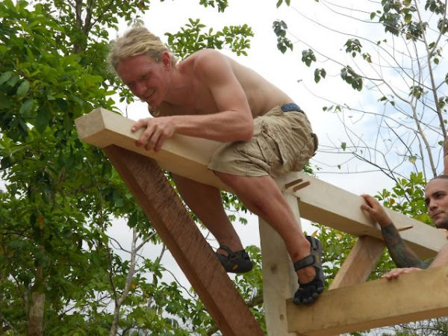
Marty on the Rafter Plate

Inspirational Impressions: Twain
"In the beginning of a change, the patriot is a scarce and brave man, hated and scorned. When his cause succeeds, however, the timid join him, for then it costs nothing to be a patriot."
~ Mark Twain ~

